
SRM Institute of Science and Technology
College of Engineering and Technology
Mode of Exam
OFFLINE
School of Computing
DEPARTMENT OF COMPUTATIONAL INTELLIGENCE
SRM Nagar, Kattankulathur – 603203, Chengalpattu District, Tamilnadu
Academic Year: 2023-2024 (ODD) SET - B
Test: CLAT-1 Date: 27/06/24
Course Code & Title: 18AIE424T- ARTIFICIAL INTELLIGENCE AND INTERNET OF THINGS
Duration: 1 Hour 40 minutes
Year & Sem: IV & VII Max. Marks: 50

Course Articulation Matrix:

S.No. | Course Outcome | PO1 | PO2 | PO3 | PO4 | PO5 | PO6 | PO7 | PO8 | PO9 | PO10 | PO11 | PO12
1 | CO1 | - | - | - | - | - | - | - | - | - | - | - | -
2 | CO2 | H | - | - | H | H | - | - | - | M | L | - | H
3 | CO3 | H | - | - | H | H | - | - | - | M | L | - | H
4 | CO4 | - | - | - | - | - | - | - | - | - | - | - | -
5 | CO5 | - | - | - | - | - | - | - | - | - | - | - | -

Part - A
( 10 x 1 = 10 Marks)
Instructions: Answer all
Q. No | Question | Marks | BL | CO | PO | PI Code
1 | Prediction intervals in linear regression are wider than confidence intervals because they account for:  a. Model uncertainty  b. Prediction uncertainty  c. Both model and prediction uncertainty  d. Neither model nor prediction uncertainty | 1 | 1 | 2 | 1,4 | 1.4.1
2 | The margin in a Support Vector Machine (SVM) is defined as:  a. The distance between a support vector and the decision boundary  b. The width between the nearest data points of different classes  c. The sum of distances from all points to the decision boundary  d. The distance between the farthest data points of different classes | 1 | 1 | 2 | 1 | 1.4.1
3 | Pruning in decision trees helps to:  a. Increase the tree depth  b. Reduce overfitting  c. Enhance the complexity of the model  d. Improve the interpretability | 1 | 1 | 2 | 1 | 1.3.1
4 | In a Random Forest, each tree is trained on:  a. The same subset of the data  b. A different subset of the data  c. The entire dataset  d. Bootstrap samples of the data | 1 | 1 | 2 | 1 | 1.3.1
5 | Naïve Bayes classifiers often perform well despite their independence assumption because:  a. They are very simple models  b. Many real-world problems have independent features  c. The independence assumption reduces overfitting  d. The independence assumption only needs to hold approximately for good performance | 1 | 1 | 2 | 1 | 1.3.1
6 | Which activation function is commonly used to introduce non-linearity in a neuron model?  a. Linear  b. ReLU  c. Sigmoid  d. Softmax | 1 | 1 | 3 | 1 | 1.3.1
7 | The purpose of the activation function in a neural network is to:  a. Introduce non-linearity  b. Normalize the output  c. Perform matrix multiplication  d. Reduce the dimensionality of data | 1 | 1 | 3 | 1 | 1.3.1
8 | Compared to LSTM, GRU units:  a. Have more gates and parameters  b. Have fewer gates and parameters  c. Are more complex to train  d. Do not address the vanishing gradient problem | 1 | 2 | 3 | 1,4 | 1.3.1
9 | In an autoencoder, the encoder part:  a. Reconstructs the input data from the encoded representation  b. Compresses the input data into a latent-space representation  c. Classifies the input data  d. Applies pooling operations to the input data | 1 | 1 | 3 | 1 | 1.3.1
10 | In practice, Line of best fit or regression line is found when _____________  a. Sum of residuals (∑(Y – h(X))) is minimum  b. Sum of the absolute value of residuals (∑|Y-h(X)|) is maximum  c. Sum of the square of residuals ( ∑ (Y-h(X))2) is minimum  d. Sum of the square of residuals ( ∑ (Y-h(X))2) is maximum | 1 | 2 | 3 | 1 | 1.3.1
Part – B
( 4 x 5 = 20 Marks)
Instructions: Answer any 4
11 | Explain how back propagation algorithm is used to train the Multi-layer Perceptron. | 5 | 1 | 3 | 1 | 2.1.1
12 | Explain the fundamental principles of linear regression and how it is applied in statistical modeling and predictive analysis? | 5 | 2 | 2 | 1,5 | 2.1.1
13 | Explain how the CNN works and the concept behind kernel, padding, and strides. | 5 | 2 | 3 | 1 | 2.1.1
14 | What is the purpose of pooling layers in CNNs, and how do they contribute to feature reduction? | 5 | 1 | 3 | 1 | 2.1.1
15 | Consider a sample of 40 students; we have three variables: the gender (boy or girl; discrete), class (XI or XII; discrete), and height (5 to 6 feet; continuous). Eighteen students prefer to go to the library in their spare time and rest prefer to play. Explain how to build a decision tree to predict who will be going to the library and who will be going to the playground in their leisure time. | 5 | 3 | 2 | 1 | 2.1.1
PART – C
(2x 10 =20 Marks)
Instructions: Answer any 2
16 | a) You work at a manufacturing plant and need to build a system for fault detection in the production line. How can SVMs be applied to identify faulty products, and what sensor data or features might be relevant?  or  b) (i) What is the concept of "voting" in ensemble methods, and how is it used in techniques like Random Forests and Ensemble Learning? ? [5 marks]  (ii) How do you assess the goodness of fit in a linear regression model, and what are common evaluation metrics used for regression, such as R-squared and Mean Squared Error (MSE)? [5 marks] | 10 | 2 | 2 | 1,5 | 2.3.1
17 | a) (i)What is the role of dropout and batch normalization in regularizing CNNs and improving their generalization performance? [5 marks]  (ii) How does the concept of weight sharing in CNNs lead to a significant reduction in the number of learnable parameters, and why is this an advantage for training deep networks?[5 marks]  OR  b) (i)What is the motivation behind the development of GRU, and how does it differ from LSTM in terms of architecture? [5 marks]  (ii) Explain the components of a GRU cell, including the update gate and reset gate, and how they influence the information flow. [5 marks] | 10 | 3 | 3 | 1,4 | 2.3.1

Course Outcome (CO) and Bloom’s level (BL) Coverage in Questions

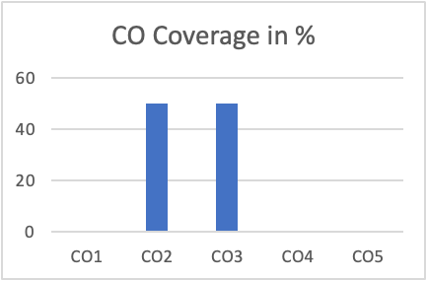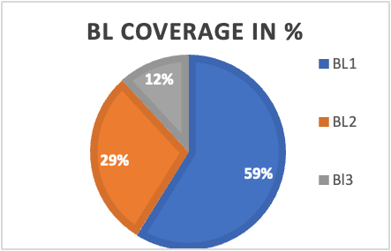
Approved by the Audit Professor/Course Coordinator

